WEB PROGRAMMING QUIZ 1 REPORT

1. The design concepts and structure of your website.

The design is inspired by YouTube user interface with its dark theme and glass like navigation bar. That’s why the majority of the website is full of image rather than text with some variation unlike YouTube that have text on the bottom of the video thumbnail. I put the text beside the image to make context to the image. At first, I make the website scrollable but later I read the requirement need to use page routing so I separate all the section (that’s why every page is short) into different part and assemble them to 1 index.html file which connect to the main.css (the style) and the script.js (the page routing code). Since the page routing using index.html it basically just inserts part of the code from page html (e.g. profile) to the index.html.

1. Screenshots of the final webpages.

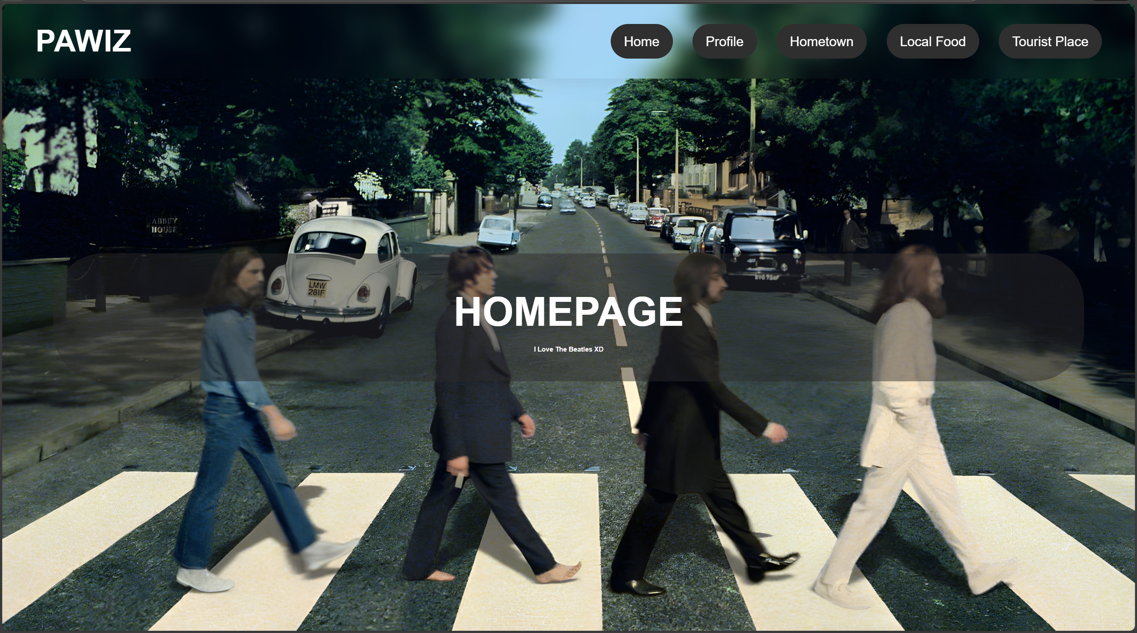

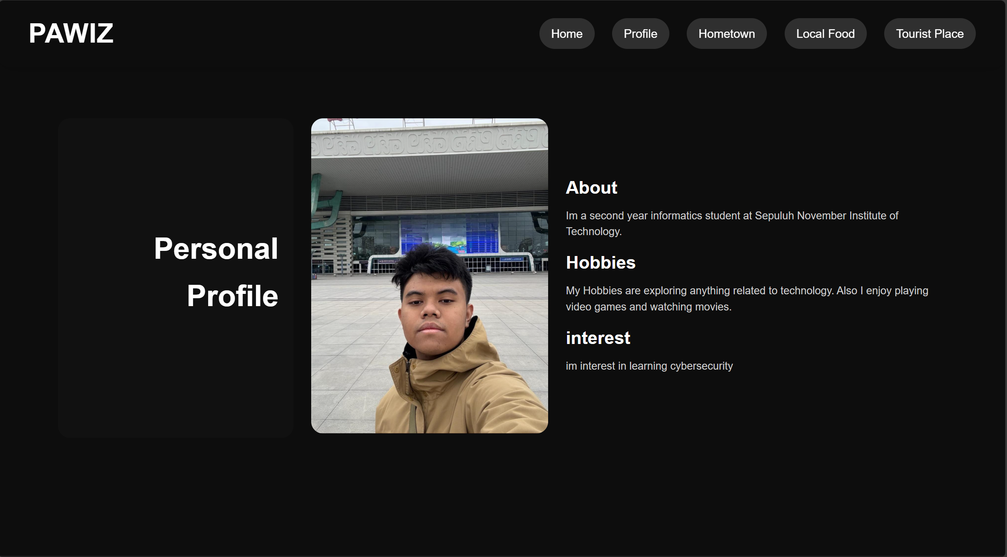

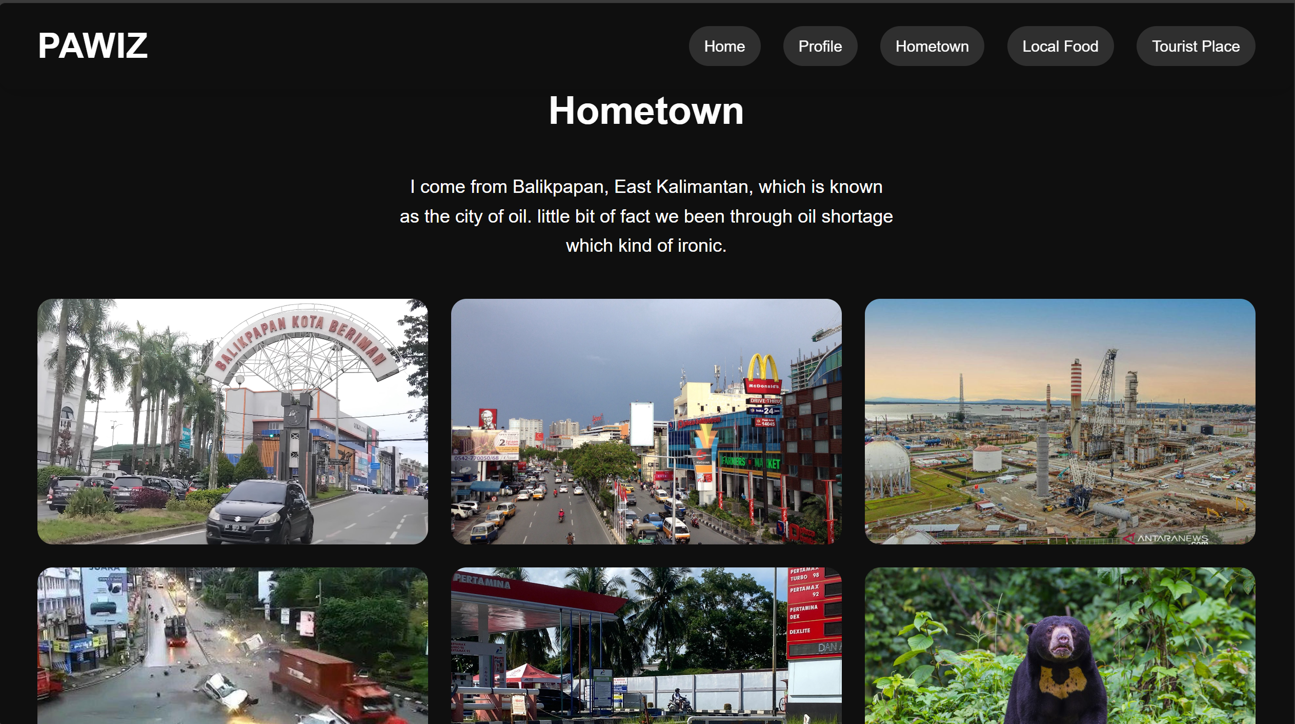

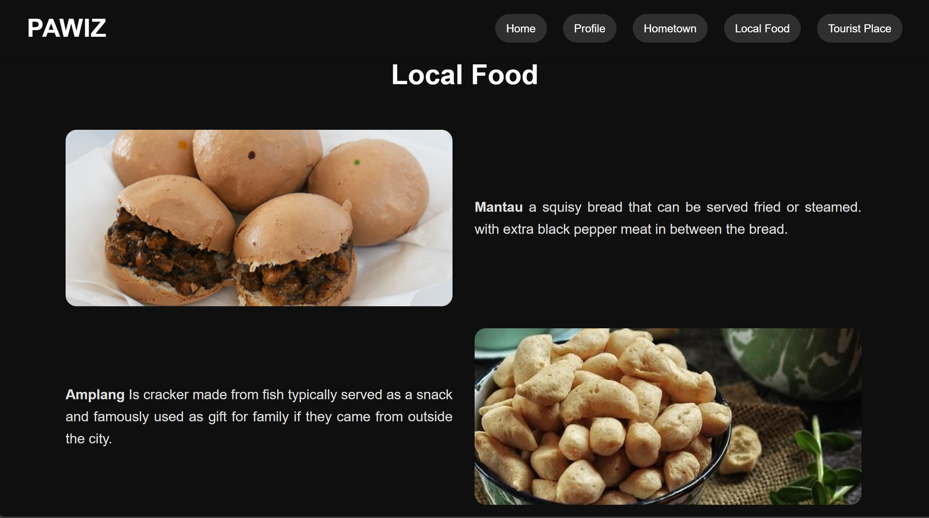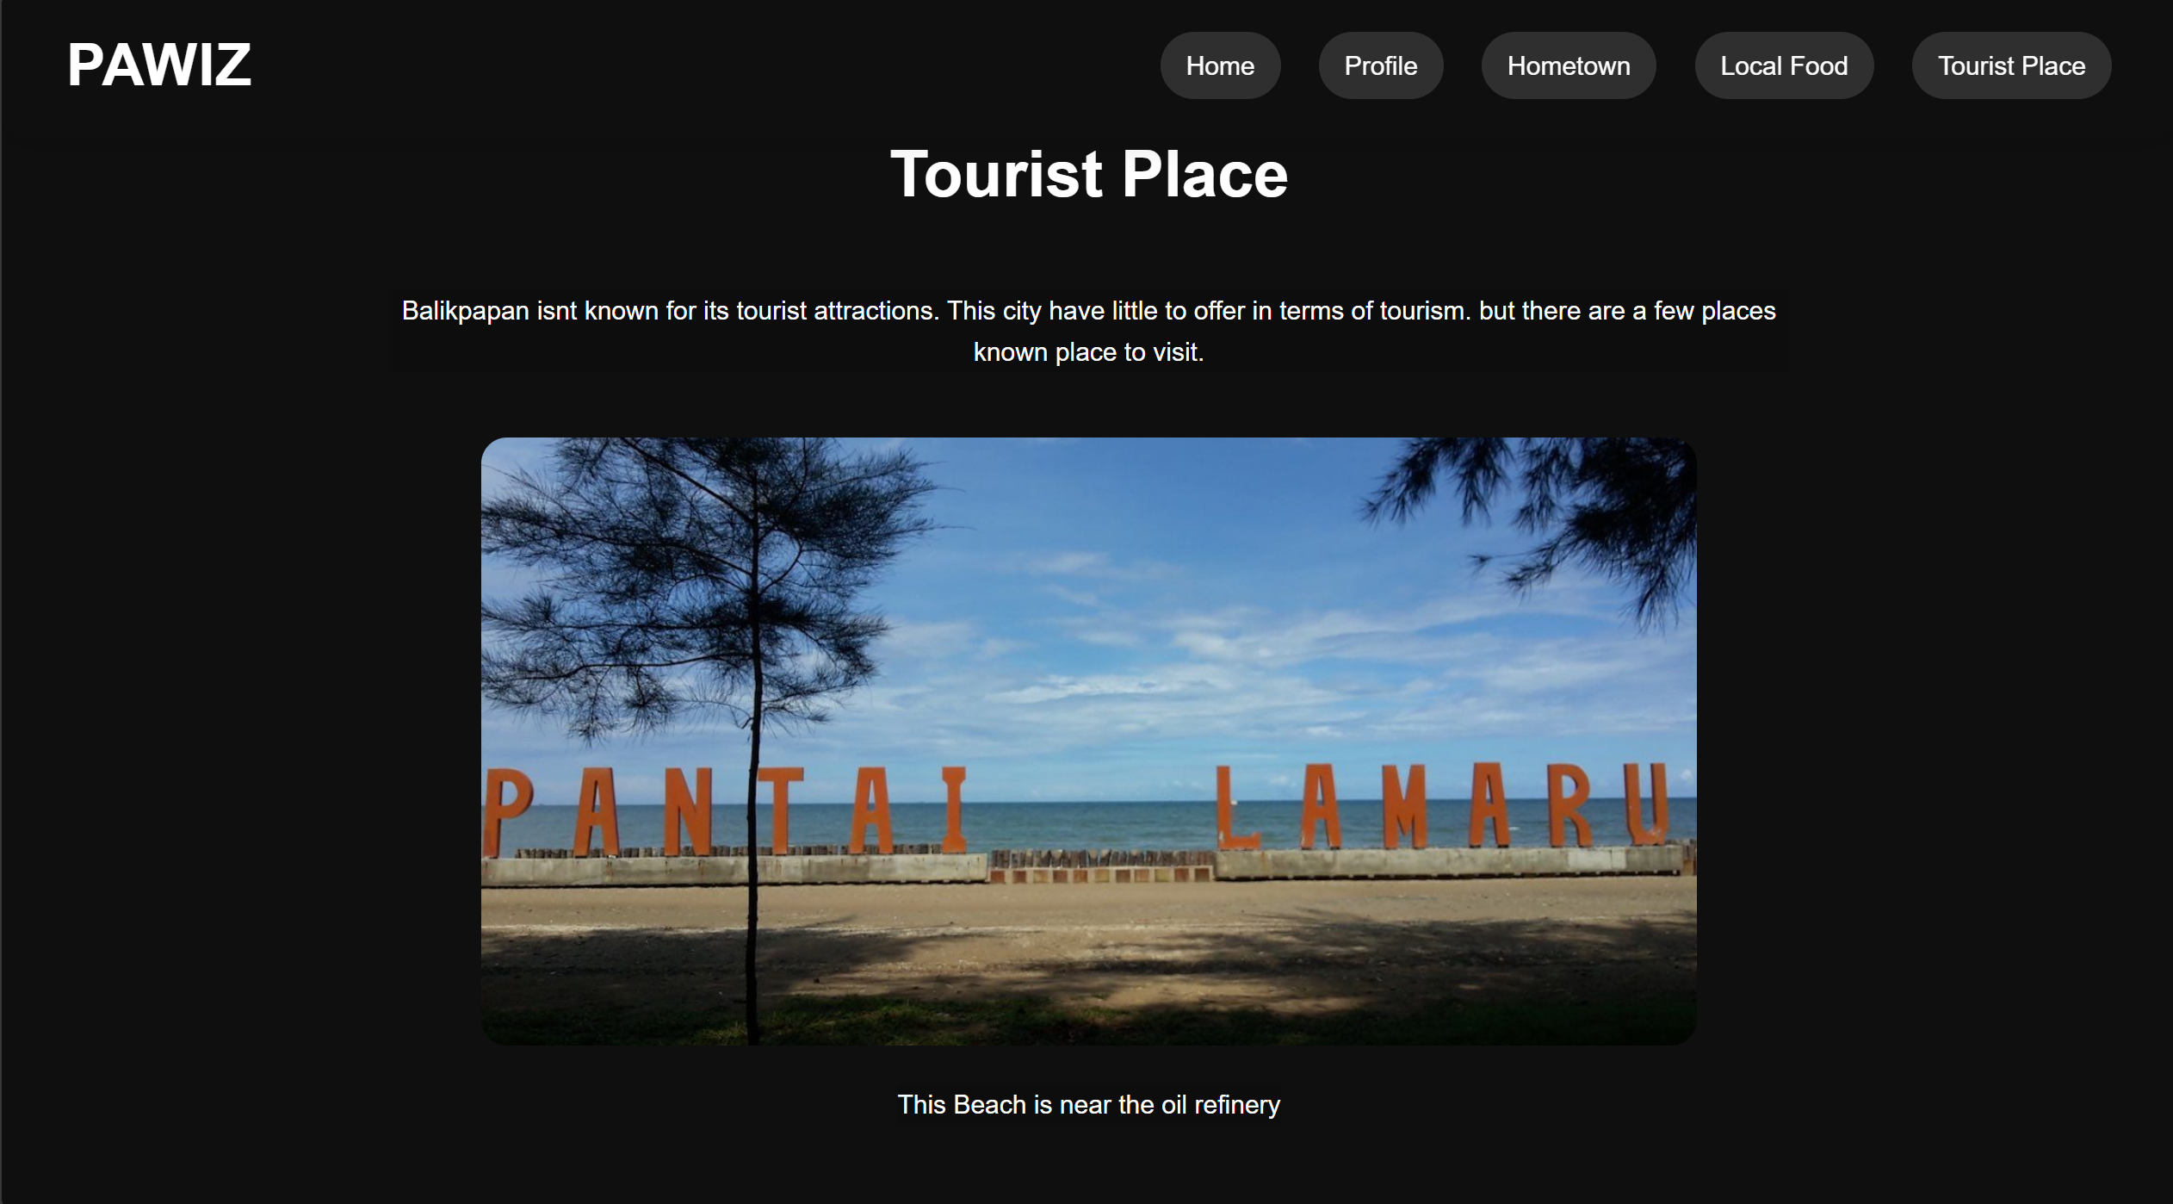

1. The website I make is a basic website with the use of HTML, CSS, and JavaScript. JavaScript is only use to make a page routing.

There are 6 HTML file

|  |  |
| --- | --- |
| File name | code |
| Index.html | <!DOCTYPE html>  <html lang="en">  <head>    <meta charset="UTF-8">    <meta name="viewport" content="width=device-width, initial-scale=1.0">    <link rel="stylesheet" href="Main.css">    <link rel="stylesheet" href="https://cdnjs.cloudflare.com/ajax/libs/font-awesome/6.5.2/css/all.min.css">    <title>Website</title>  </head>  <body>    <header>      <a href="#/quiz1" class="logo" onclick="route(event)">PAWIZ</a>    <nav>      <a href="#/quiz1" onclick="route(event)">Home</a>      <a href="#/quiz1/profile" onclick="route(event)">Profile</a>      <a href="#/quiz1/hometown" onclick="route(event)">Hometown</a>      <a href="#/quiz1/food" onclick="route(event)">Local Food</a>      <a href="#/quiz1/tourist" onclick="route(event)">Tourist Place</a>    </nav>    </header>    <div id="root"></div>    <script src="script.js"></script>  </body>  </html> |
| CSS | * {    margin: 0;    padding: 0;    box-sizing: border-box;  }  body {    font-family: Arial, Helvetica, sans-serif;    background: #0f0f0f;    color: #fff;    line-height: 1.6;    scroll-behavior: smooth;  }  header {    position: fixed;    top: 0;    left: 0;    width: 100%;    padding: 20px 50px;    display: flex;    justify-content: space-between;    align-items: center;    z-index: 10000;    background: rgba(255, 255, 255, 0);    border-radius: 16px;    box-shadow: 0 4px 30px rgba(0, 0, 0, 0.1);    backdrop-filter: blur(13.8px);    -webkit-backdrop-filter: blur(13.8px);  }  header .logo {    color: #fff;    font-size: 45px;    font-weight: bold;    text-decoration: none;    letter-spacing: 1px;  }  header nav a {    color: #fff;    text-decoration: none;    margin-left: 25px;    font-size: 20px;    padding: 15px 20px;    border-radius: 30px;    transition: 0.3s;    background: #2f2f2f;  }  header nav a:hover{    background: #ffffff;    color: #424242;  } |
| Explanation | This is basic html template with head that have information in head such as meta charset, link to css and connect to font. In there the title is website. The body have the header for navigation for each page. There is script that connect to the JavaScript code for page router. With “onclick="route(event)” is for the page router to work.  This is basic header css code with left filled with logo and the right part have 5 button for page routing, also added header navigation for when the cursor hovering on the one of navigation button it changes colour. |
| Homepage  .html | <section class="Home">    <div class="Home-content">      <h1>HOMEPAGE</h1>      <p>I Love The Beatles</p>    </div>  </section> |
| CSS | .Home {    height: 100vh;    background-image: url("Beatles.jpg");    background-size: cover;    display: flex;    justify-content: center;    align-items: center;    background-position: center;    position: relative;  }  .Home-content {    color: rgb(255, 255, 255);    font-size: 50px;    font-weight: bold;    /* background: linear-gradient(135deg, #363636, #feb47b);  */    background: #2b2a2a76;    padding: 40px 600px;    border-radius: 75px;  }  .Home h1 {    font-size: 60px;  }  .Home-content p {    font-size: 10px;    text-align: center;  } |
| Explanation | This is basic section html which just show h1 and paragraph  the css make an image fullpage and then make it centred with back position.  Home-content add background padding and border radius, and. h1 make font size 60px |
| Profile.html | <section class="Profile">    <div class="Profile-content">      <div class="pp_text">        <h1>Personal Profile</h1>      </div>      <div class="Profile-img">        <img src="./quiz1/WhatsApp Image 2025-09-19 at 07.17.47_9ec5e42b.jpg" alt="">      </div>      <div class="profile_text">        <div class="Hobbies">          <h1>About</h1>          <p>Im a second year informatics student at Sepuluh November Institute of Technology.</p>        </div>        <div class="Hobbies">          <h1>Hobbies</h1>          <p>My Hobbies are exploring anything related to technology. Also I enjoy playing video games and watching movies.</p>        </div>        <div class="Hobbies">          <h1>interest</h1>          <p>im interest in learning cybersecurity</p>        </div>      </div>    </div>  </section> |
| css | .Profile{    background-color: #0d0d0d;    border-bottom: #ffffff14 3px solid;  }  .pp_text {    font-size: 20px;    padding: 20px;    background-color: #111111;    padding: 180px 25px 180px 100px;    border-radius: 20px;  }  .pp_text h1 {    font-size: 50px;    margin-bottom: 20px;    text-align: end;  }  .Profile {    padding: 120px 50px;    min-height: 100vh;    display: flex;    justify-content: center;    align-items: center;  }  .Profile-content {    display: flex;    align-items: center;    justify-content: center;    gap: 30px;    width: 100%;    max-width: none;    padding: 0 50px;  }  .Profile-content img {    width: 400px;    height: auto;    border-radius: 20px;    object-fit: cover;    object-position: bottom;  }  .profile_text {    gap: 50px;  }  .profile_text h1 {    font-size: 30px;    margin-bottom: 10px;    color: #fff;  }  .profile_text p {    font-size: 18px;    line-height: 1.5;    color: #ccc;    margin-bottom: 15px;  } |
| Explanation | This makes 3 parts in page title, image and 3 personal information the title is align on right with background surrounding it. The picture crops the image given and position it below since the selfie is a bit down, it also crops using margin to 400px and border radius to make it round.  The text is controlled by 1 div (profile_text) with gap 50px |
| Hometown .html | <section class="Hometown">    <div class="Hometown-content">      <h1 class="H3_title">Hometown</h1>      <p>I come from Balikpapan, East Kalimantan, which is known as the city of oil. little bit of fact we been through oil shortage which kind of ironic.</p>      <div class="img_folder">        <img src="./quiz1/BPP1.jpg" alt="">        <img src="./quiz1/BPP2.jpg" alt="">        <img src="./quiz1/BPP3.jpg" alt="">        <img src="./quiz1/BPP4.jpg" alt="">        <img src="./quiz1/BPP5.jpg" alt="">        <img src="./quiz1/BPP6.jpeg" alt="">      </div>    </div>  </section> |
| css | .Hometown {    padding: 100px 20px;    min-height: 100vh;  }  .H3_title {    font-size: 50px;    text-align: center;    margin-bottom: 40px;  }  .img_folder {    display: grid;    grid-template-columns: repeat(3, 1fr);    margin-right: 30px;    margin-left: 30px;    gap: 30px;  }  .img_folder img {    width: 100%;    height: 320px;    object-fit: cover;    border-radius: 20px;  }  .Hometown-content p{    text-align: center;    margin-top: 20px;    font-size: 24px;    margin-bottom: 50px;    padding: 0 500px;  } |
| Explanation | This one is just h1 as title, p for little bit of explanation and 6 grid of image. H1 is centred. The p also centred with padding. For the image grid it needs to display grid with template of 3 so it limits the image for a layer to be only three and to make sure it has the same spacing add margin left and right the same with the gap which is 30px. And the image itself needs to be rounded corner and the same size with limited height of 320px since it already limited the width 100% would be the same for all image. |
| Local food .html | <section class="Local-food">    <div class="Local-food-content">      <h1 class="H4_title">Local Food</h1>      <div class="local_food_img">        <img src="./quiz1/Mantau.jpg" alt="">        <div class="food_text">          <p><b>Mantau</b> a squisy bread that can be served fried or steamed. with extra black pepper meat in between the bread.</p>        </div>        <div class="food_text">          <p><b>Amplang</b> Is cracker made from fish typically served as a snack and famously used as gift for family if they came from outside the city.</p>        </div>        <img src="./quiz1/amplang.jpeg" alt="">        <img src="./quiz1/Kepiting.jpg" alt="">        <div class="food_text">          <p><b>Kepiting</b> a crab dish that is popular in Balikpapan, often served with spicy sauce.</p>        </div>        <div class="food_text">          <p><b>Nasi Kuning Haji Daud</b> a Personal favorite dish. its diffrent from other nasi kuning since it is less sweat compare to java's version and more toward spicy</p>        </div>        <img src="./quiz1/naskun.jpeg" alt="">      </div>    </div>  </section> |
| css | /* local food */  .Local-food {    padding: 100px 20px;    min-height: 100vh;  }  .H4_title {    font-size: 50px;    text-align: center;    margin-bottom: 60px;  }  .local_food_img {    display: grid;    grid-template-columns: 700px 700px;    align-items: center;    gap: 40px;    margin: 40px 100px;  }  .local_food_img img {    width: 100%;    height: 320px;    object-fit: cover;    border-radius: 20px;  }  .local_food_img .food_text {    font-size: 25px;    color: #ddd;    text-align: justify;  } |
| explanation | This page has the same idea with the previous page. The different is that it only limited to 2 grid and instead of all picture the there are text so it switches between image and text. And also, the size of each image is wider since it going to fill the screen. Since I don’t want to make another h1 per food info which going to destroy the grid I just change the title name with <b> so we can tell what is the image without adding destroying the grid |
| Tourist _Place.html | <section class="Tourist-place">    <div class="Tourist-place-content">      <h1 class="H5_title">Tourist Place</h1>      <p>Balikpapan isnt known for its tourist attractions. This city have little to offer in terms of tourism. but there are a few places known place to visit.</p>      <div class="img_folder2">        <img src="./quiz1/lamaru.jpeg" alt="">        <p>This Beach is near the oil refinery</p>        <img src="./quiz1/teritip.jpg" alt="">        <p>We keep crocodile here</p>        <img src="./quiz1/sungai wain.jpeg" alt="">        <p>A nature site that keeps various of plant and animals</p>        <img src="./quiz1/kebray.jpg" alt="">        <p>This place is usually held an scout event for schools. it also keep many plants as a source of education for students to learn about nature.</p>      </div>    </div>  </section> |
| css | .Tourist-place-content p{    background-color: #0d0d0d;    align-items: center;    text-align: center;    margin-left: 300px;    margin-right: 300px;    margin-bottom: 50px;    font-size: 20px;  }  .H5_title {    font-size: 50px;    text-align: center;    color: #fff;    padding: 100px 50px 50px 50px;  }  .img_folder2 {    gap: 30px;    align-items: center;    justify-items: center;    padding: 0 70px;    display: grid;  }  .img_folder2 img {    width: 100vh;    height: 50vh;    object-fit: cover;    border-radius: 20px;  } |
| explanation | Now the last part is 1 grid so the image moves to bottom, with same border radius and now in html it switches between title, image, then text. The structure of the page is almost identical to two previous pages. The only different is the placement of the title, image and paragraph. |
| Script.js | const routes = {    "#/quiz1": "quiz1/Homepage.html",    "#/quiz1/profile": "quiz1/Profile.html",    "#/quiz1/hometown": "quiz1/Hometown.html",    "#/quiz1/food": "quiz1/Local_Food.html",    "#/quiz1/tourist": "quiz1/Tourist_Place.html"  };  const route = (event) => {    event.preventDefault();    const href = event.currentTarget.getAttribute("href");    window.location.hash = href;  };  const handleLocation = async () => {    const path = window.location.hash || "#/quiz1";    const routePath = routes[path];    if (routePath) {      const html = await fetch(routePath).then(res => res.text());      document.getElementById("root").innerHTML = html;    }  };  window.addEventListener("hashchange", handleLocation);  window.route = route;  handleLocation(); |
| explanation | First, we add const for the location of the location of html on the pages.  when a nav link clicked, stop the default page reload, get the links href, and update the URL so the router loads the correct html file.  If a route exists, it loads the html file, converts it to text, and inserts it into the root element in index.  Last 3 line update the page when the link changes and show the right page at the start. |

1. An analysis or evaluation of your project

These is a simple website project that use simple page routing so it has different html file for every page. Some part of the website feel empty since there are no specific requirement for the body website, that’s why there is more image rather than text. An evaluation for this project is that at first, I though it going to be scrollable website where everything in one page. Also, since I chose JavaScript as page routing script there are less tutorial on YouTube so there are struggle to debug the script for the page routing. This website is also not adaptive to different screen resolution so the format is going to change in different devices. And also, there are no error handling in this website, so any issues to load the website happen because my limited knowledge of JavaScript. There are also less transition and styling to the website which result on the website feel static.

1. Conclusion  
   The website I implemented works by putting the html section into the index. So, it fully does the page routing. The interaction between button navigation works even without error handling, which it not tested for any error yet. Another limitation is that it lacks of styling and responsiveness to the other devices. Overall, it does the basic html CSS and JavaScript, with minimal design and implement page routing